Van Isle Water Proofing+ — Input & Decisions We Need From You
A single checklist of everything we're waiting on from you, so nothing slips through the chat. No rush — work through it whenever suits. You can answer right in this doc (there's a space under each item),
Last updated: July 2026
How to read the priorities: 🔴 = needed to make the tools show your real data · 🟡 = fills in the People/Crew tool · 🟢 = a decision to confirm · ⚪ = just a heads-up / ready when you are

A. Inventory & warehouse data (Warehouse Wizard)
🔴 A1. Finish the inventory spreadsheet — three columns matter most
We've loaded your 121 real items, but many are missing key fields. To prioritize, please fill these in the sheet:
• Unit (locked) — Added
• On Hand (current quantity) — This will be updated by August 5
• Unit Cost ($) — This will be updated by August 5 and added to column I. This new column will show price variations as I’m requesting the latest prices.
🟡 A2. Inventory categories — optional cleanup
These are correct

The sheet is important to include in the live version as it is why we created the app. The crew needed strict quantities and product names to properly log what they were using at sites by the end of each day.
We will add the remaining quantities for this month by August 5.
Once this is live, the crew has to use this tool to log their daily materials/inventory usage: https://docs.google.com/spreadsheets/d/1EKxNsSK7GyZ3OYhTupU9XLWnv9tgj79SoyFF-jE0Ck0/edit?gid=1106532455#gid=1106532455

I will need a nudge to add in any missing inputs between August 5 and when the team starts using it so we don’t miss any logs.

FYI - I need to be able to export a spreadsheet or show a clear usage list of the DAILY INVENTORY LOG at the end of each month for our accounting team to track.

B. People, performance & compliance (Crew+)
🟡 B1. KPI targets per role
We've built the KPI framework per role (Crew Lead, Technician, Senior Tech, Ops/Marketing/Accounting, CFO) but left the actual target numbers blank. Please provide your real targets so they go live.
Your input:
This will be ready by August 15 at the latest

🟡 B2. Bonus program
• Please send your current bonus program document — we'll map it onto the transparent "profit pool → scorecard → December payout" model (using your real profit %, role weights, and any floors/caps).
• Do you approve that model in principle?
Your input:
This will be ready by August 15 at the latest

🟡 B3. Certification expiry dates
The compliance tracker is seeded with your real roster, but most certs have no expiry date on file — and those dates are what power the 60/30/7-day renewal alerts. Please provide them, prioritizing Fit Test and First Aid (they lapse most). Also, please confirm/action the gaps we already flagged:
• Jesse — Level 1 First Aid: expired (needs renewal)
• Jesse — Fit Test: dated Sep 2025, so likely overdue
• Logan — no certifications on file (data gap, or real gap?)
• Shane — only "Lift" on file (missing WHMIS / First Aid / Fit Test records?)
Your input:
This will be ready by August 15 at the latest

🟡 B4. Company values — keep or reword?
We seeded five starter values (Safety First · Do It Right the First Time · Own the Outcome · Leave It Better · Grow the Crew), each with daily/weekly/monthly rituals. Are these yours to keep, or would you like to reword them to sound like your company? (This is the most personal part — worth making it yours.)
Your input:
This will be ready by August 15 at the latest

🟢 B5. Rewards catalog & point value — one decision needed
• Keep $0.25/point and re-price the rewards catalog upward
Rewards can be used at the end of every quarter. If they don’t collect their points, they will continue to accumulate.

October 31, January 31, April 30, July 31

Rewards should be: Cash, Gift Card, PTO

🟢 B6. Confirm the points-earning table
Please confirm the full list of point values is final (or flag changes) —
- Perfect truck-task day +25
- 5-day streak +25
- Approved SOP +20
- 5★ Google review +200
- Daily/weekly/monthly rituals, safety milestones, peer recognition, etc. + 5
🟢 B7. Google review QR codes
Your notes mention a per-person Google review QR code crew can show customers to earn points (+200 for a 5★ review naming them). Confirm you want this in Crew+ and we'll wire it up.

Yes. Google review link: https://www.google.com/maps/place//data=!4m3!3m2!1s0x548f6b3774eb6afd:0xbd3374f825d460ba!12e1?source=g.page.m._&laa=merchant-review-solicitation

Please give Jesse, Jon & Jordan 200 points each as they recently received a review
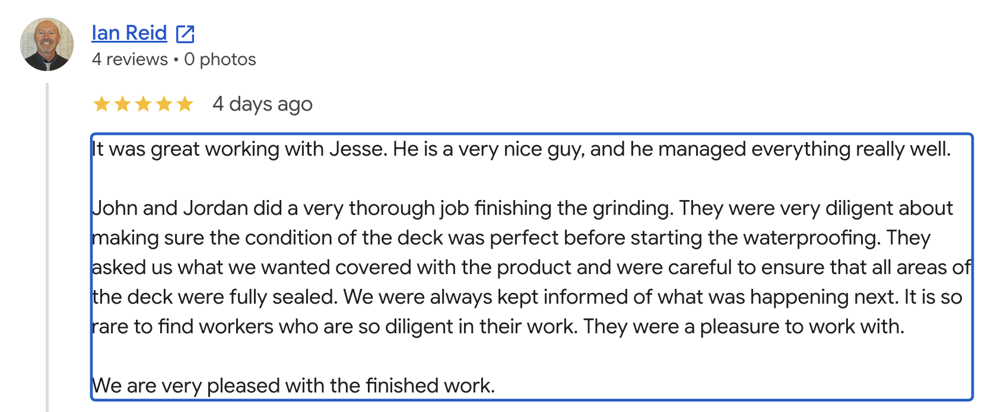

C. Ready when you are (no action needed yet — just flagging)
⚪ C1. QuickBooks live connection
You've already granted admin access — thank you. When we reach the go-live step, we'll need an admin available for ~5 minutes to authorize the connection. We'll only pull customer name + job name for "In Progress" jobs. Just let us know a good time when we're ready.

Ready after all spreadsheets are 100% Complete

For reference — things you've already decided (no action needed)
So you know these are locked in and don't need revisiting:
• ✅ Platform: responsive web app (not app-store apps)
• ✅ Roles: Admin / Manager / Crew — permissions confirmed correct
• ✅ Branding: using your Van Isle brand guide (colors + fonts)
• ✅ QuickBooks Online, Projects, pull In-Progress jobs, customer + job name only
• ✅ SOP tool: +20 per approved SOP · anyone can create/earn · offline photo/video capture · published SOPs are editable (not tick-off) · anyone can edit · one-person sign-off
• ✅ Review scale: 3-tier (Below / Meets / Exceeds) for crew, optional 1–5 for office roles

